GIT WORKFLOW

Git is a mature, actively maintained open source project originally developed in 2005 by Linus Torvalds, the famous creator of the Linux operating system kernel.

A staggering number of software projects rely on Git for version control, including commercial projects as well as open-source. Developers who have worked with Git are well represented in the pool of available software development talent and it works well on a wide range of operating systems and IDEs (Integrated Development Environments).

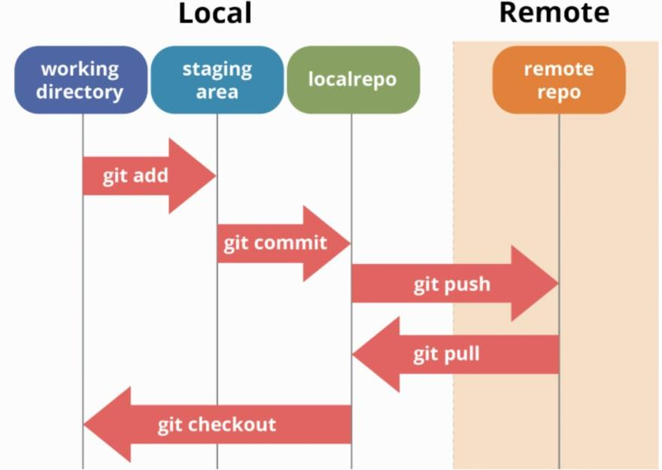

Git is the best choice for most software teams today. While every team is different and should do their own analysis, here are the main reasons why version control with Git is preferred over alternatives:

* Git has the functionality, performance, security and flexibility that most teams and individual developers need.
* Git is the most broadly adopted tool of its kind.
* Git is a very well supported open source project with over a decade of solid stewardship.
* Git enjoys great community support and a vast user base.
* Git has been designed with the integrity of managed source code as a top priority.
* Git is not fooled by the names of the files when determining what the storage and version history of the file tree should be, instead, Git focuses on the file content itself.

Installation Guide of Git:

* [Git for Mac installer](https://sourceforge.net/projects/git-osx-installer/files/).
  + $ git --version
* [Git for Windows installer](https://git-for-windows.github.io/).
  + $ git --version
* [Git for](https://git-for-windows.github.io/) Debian/Ubuntu.
  + $ sudo apt-get install git
  + $ git --version